CA Assignment 2

Muhammad Usman Hussain 12439

Q: Create a circuits using Arduino UNO and interface stepper motor with it.

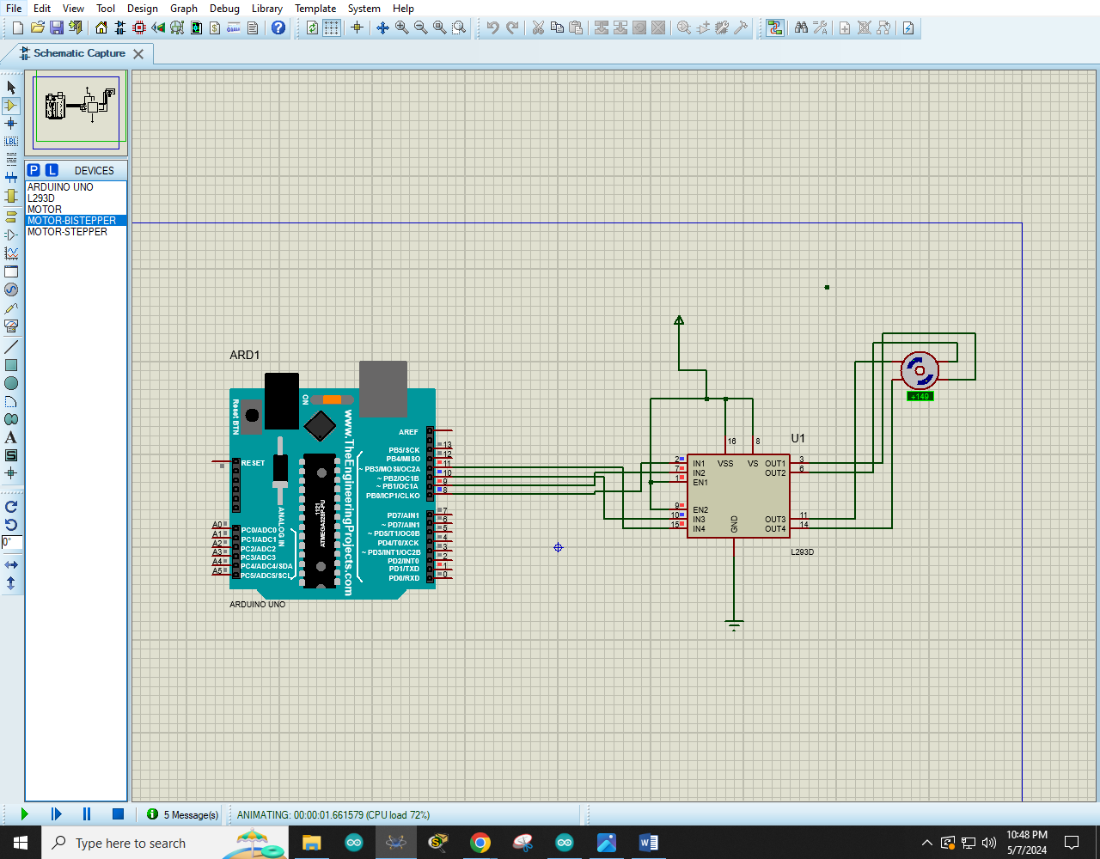

**Code:**

#include <Stepper.h>

const int spr = 4;

Stepper steper(spr, 8 , 9 ,10 ,11);

void setup(){

steper.setSpeed(60);

Serial.begin(9600);

}

void loop(){

steper.step(spr);

delay(50);

steper.step(-spr);

delay(50);

}